Wipro TalentNext – Database Solution Expert
Module 3: Using DDL Statements to Create and Manage Tables

Question 1: Create table Dept1 with columns DEPTNO (Primary Key), DNAME (VARCHAR2(30) NOT NULL), and LOC (VARCHAR2(30) NOT NULL).
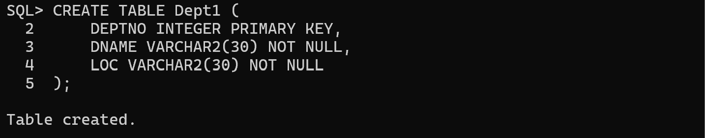
Question 2: Create table Emp1 with columns EMPNO (Primary Key), ENAME (VARCHAR2(20) NOT NULL), SAL (NUMBER(10,2) with CHECK SAL > 5000), MGR (Foreign Key referencing EMPNO), and DEPTNO (Foreign Key referencing Dept1(DEPTNO)).
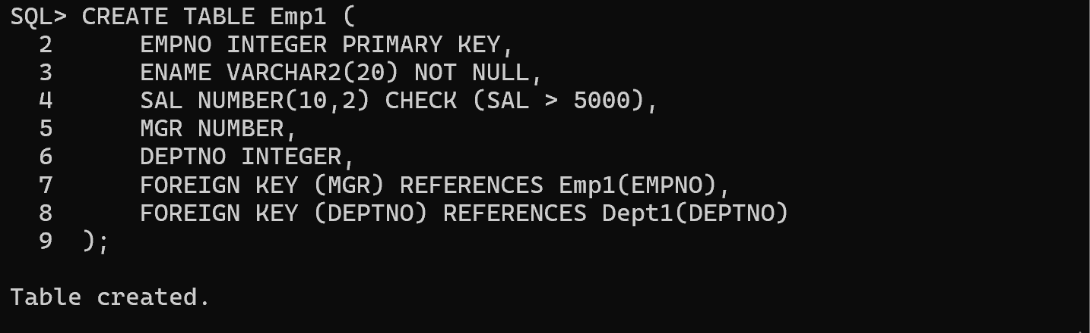
Question 3: Create tables Dept11 and Emp11 from Dept1 and Emp1.
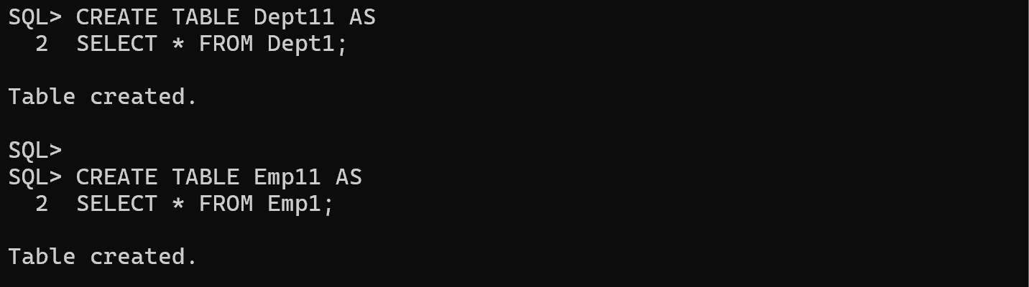
Question 4: Add a new column ADDRESS of type VARCHAR2(30) to the Emp1 table.
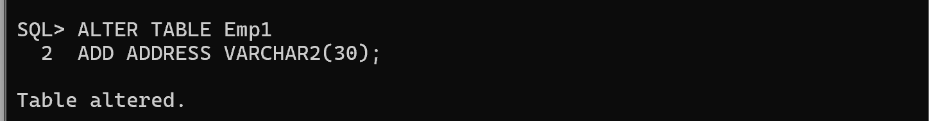
Question 5: Rename column SAL to SALARY in the Emp1 table.
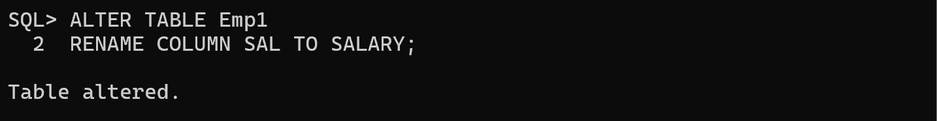
Question 6: Rename the foreign key constraint names and verify the constraint names for the Emp1 table.
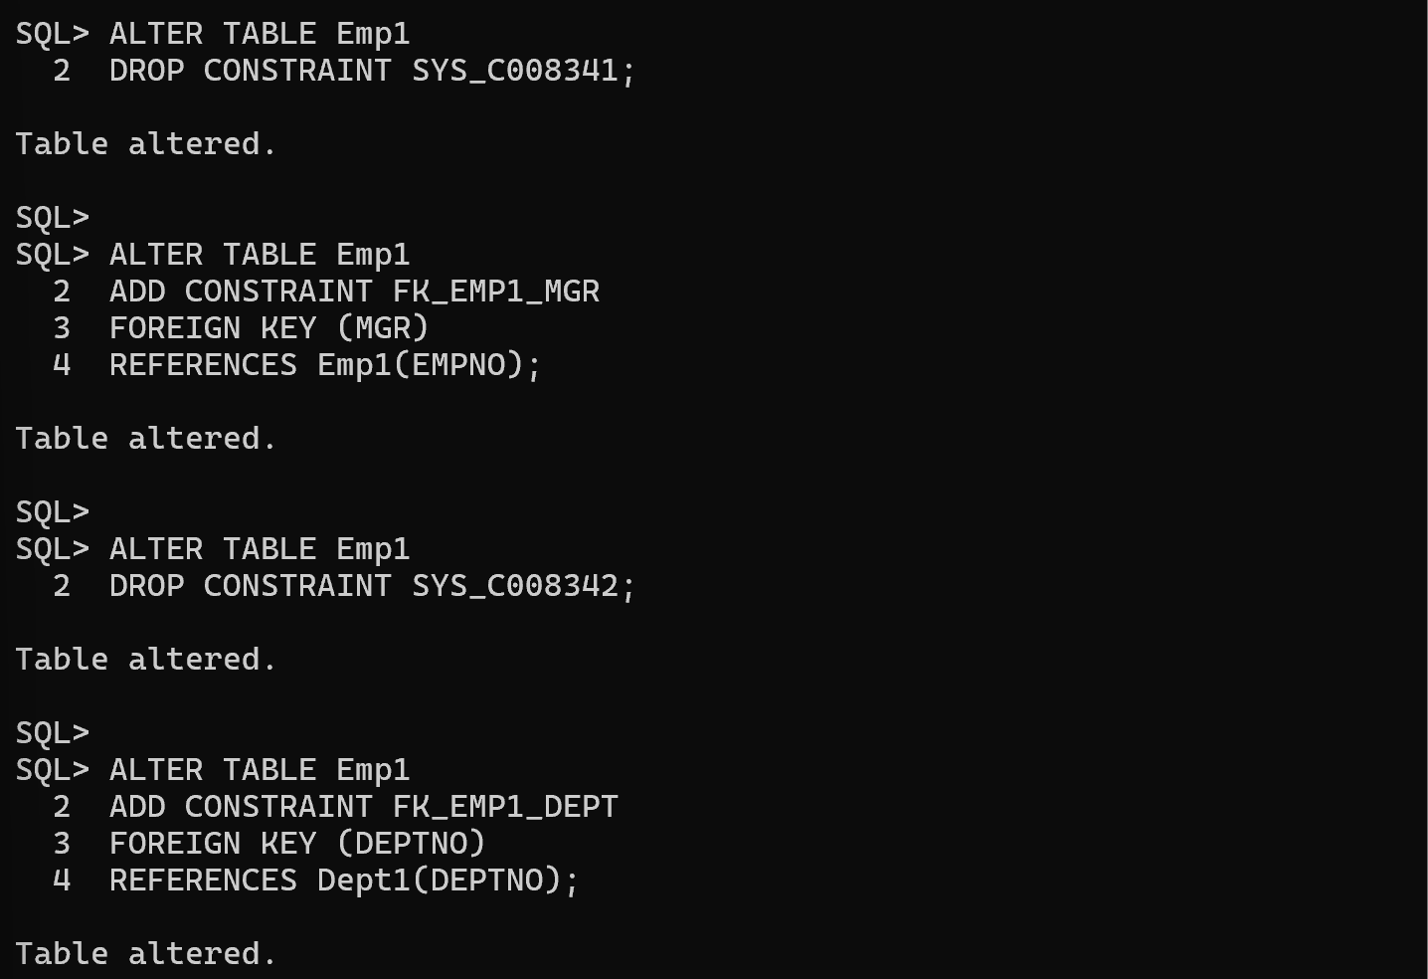
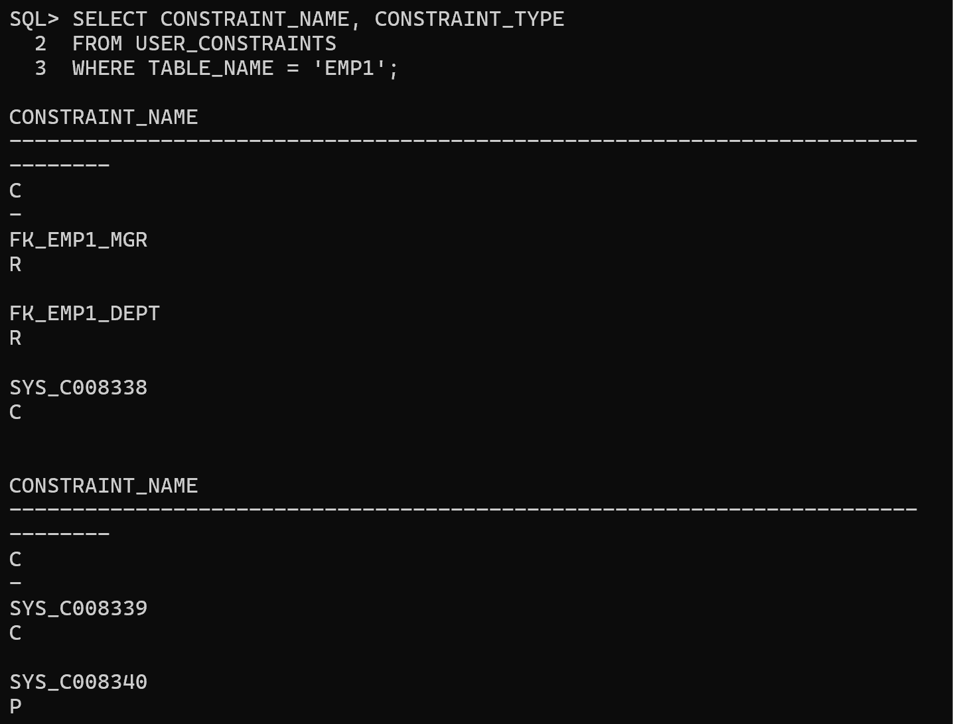
Question 7: Modify the ENAME column by increasing its size to VARCHAR2(40).
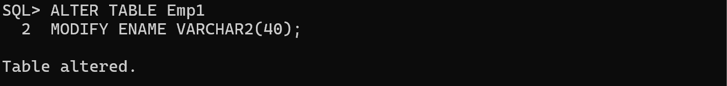
Question 8: Drop the NOT NULL constraint from the ENAME column.
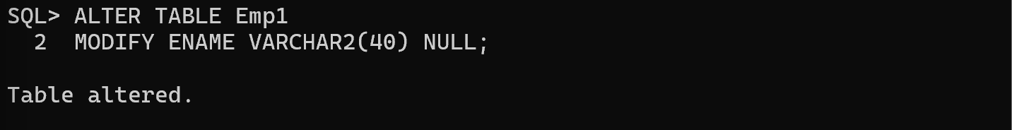
Question 9: Create a comment on the Dept1 table as 'Depts of WIPRO'.
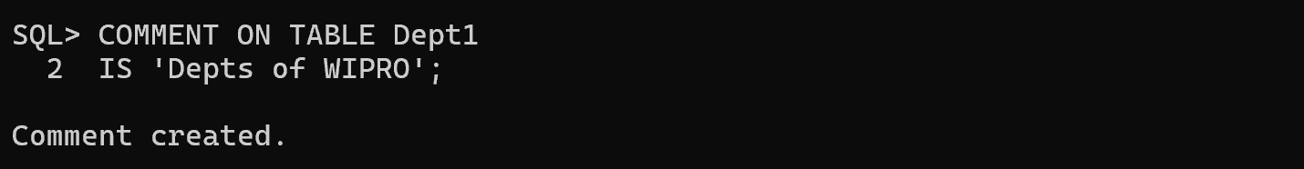
Question 10: Create a comment on the DEPTNO column of the Dept1 table as 'Deptno of WIPRO'.
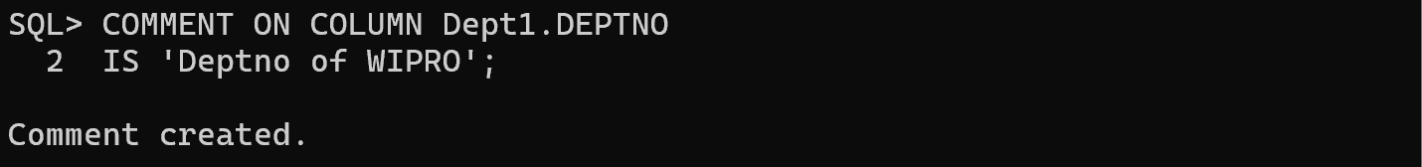
Question 11: Create a comment on the Emp1 table as 'Employees of WIPRO'.
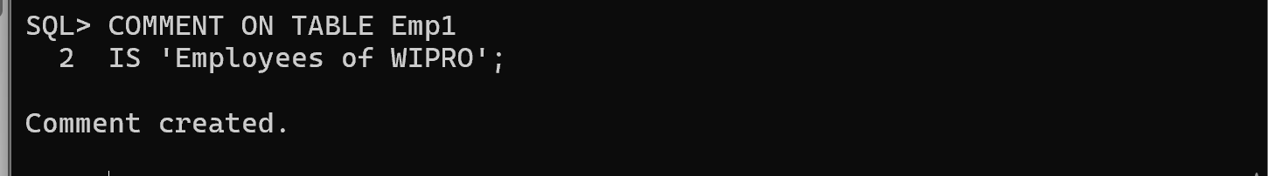
Question 12: Create a comment on the EMPNO column of the Emp1 table as 'Empno of WIPRO'.
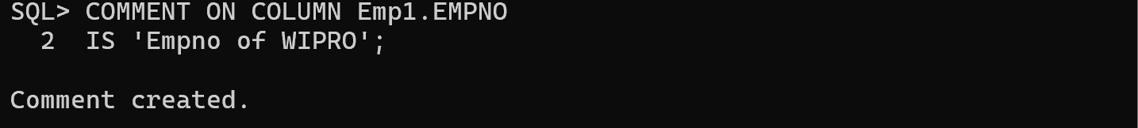
Question 13: Remove all the comments from the tables and columns.
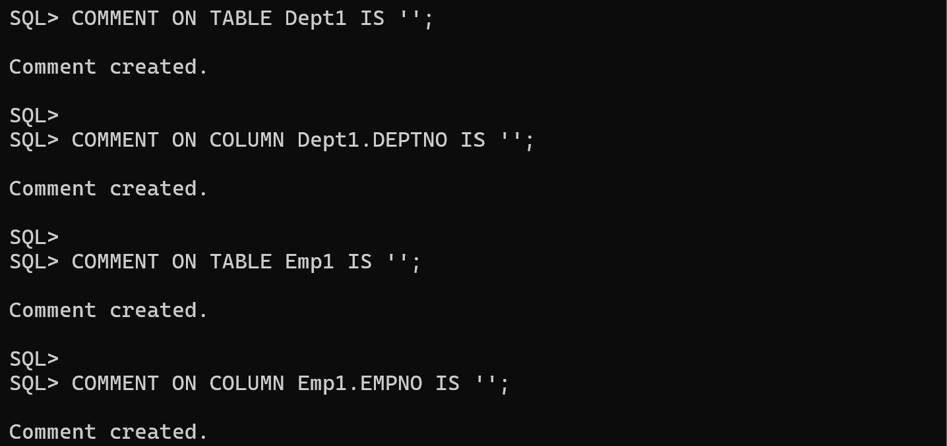
Question 14: Set the SALARY and ENAME columns of the Emp1 table as unused.
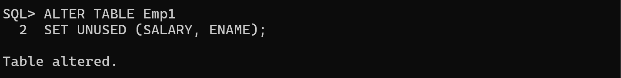
Question 15: Drop the unused columns.
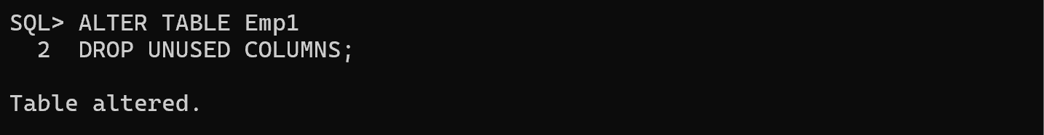
Question 16: Drop the Emp1 and Dept1 tables.
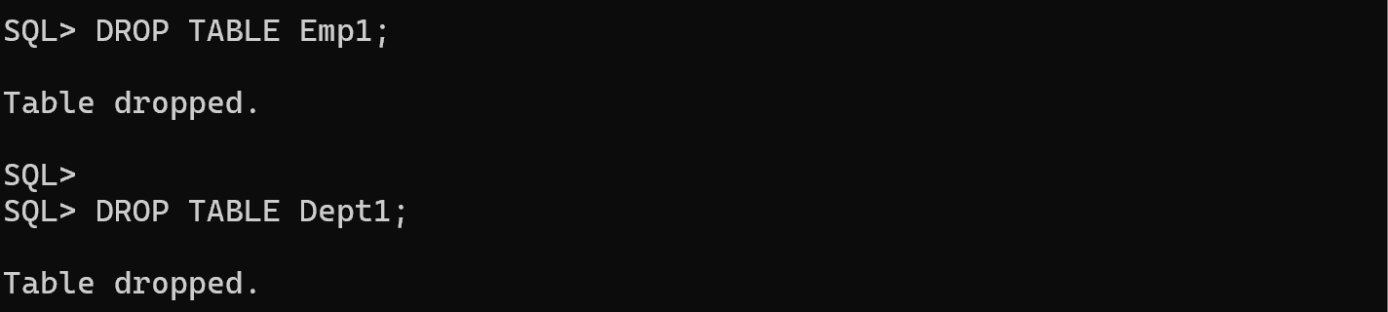
Question 17: Create table Emp1 from the EMP table by copying the data also. Check the data.
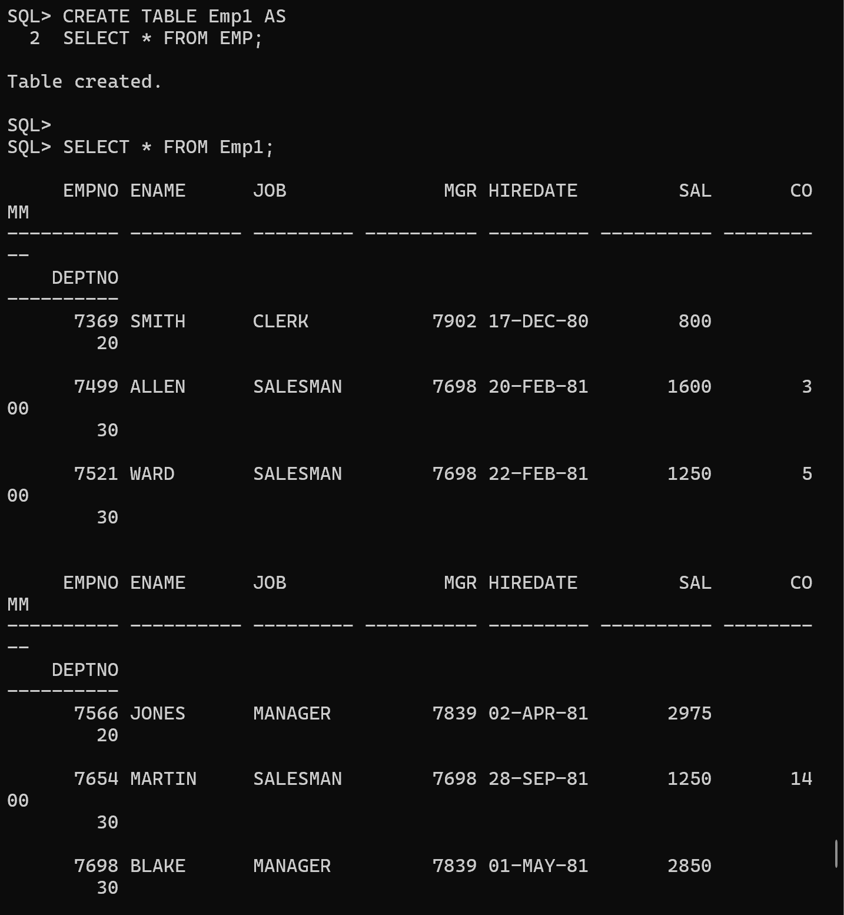
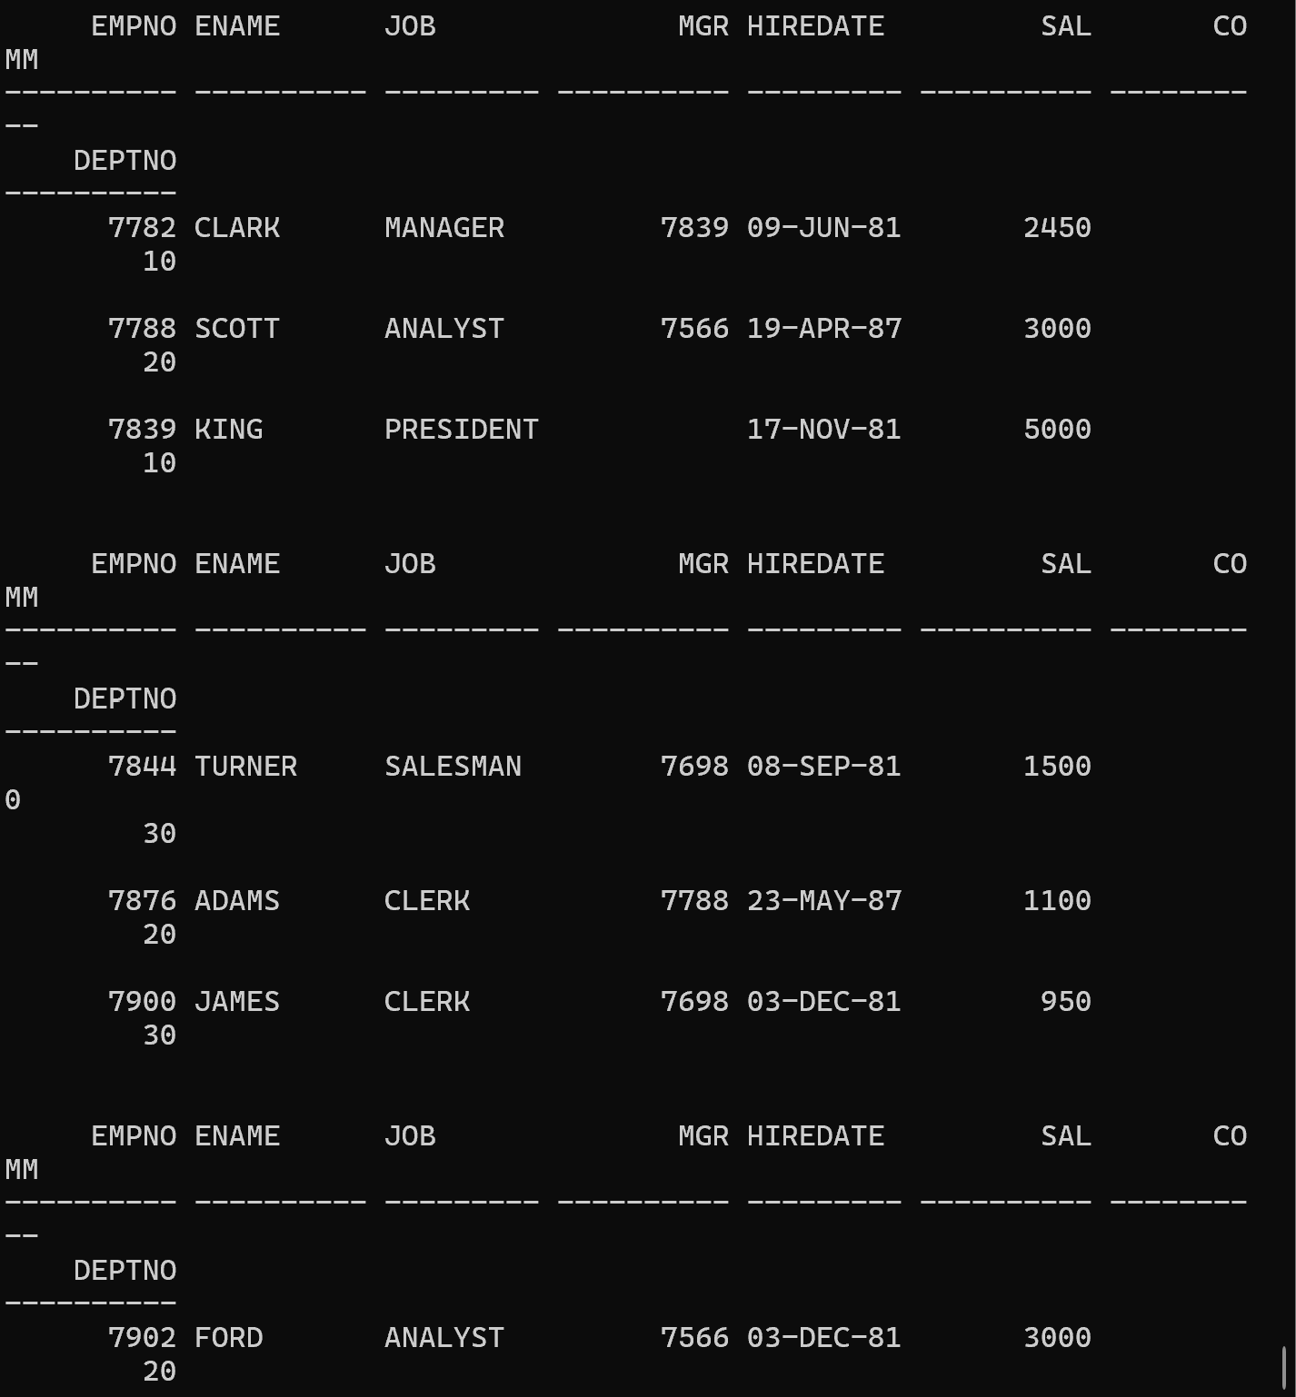
Question 18: Rename Emp1 to EMP_Test.
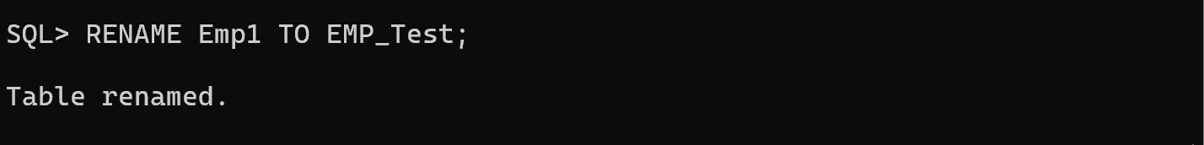
Question 19: Truncate the EMP_Test table and confirm the deletion.
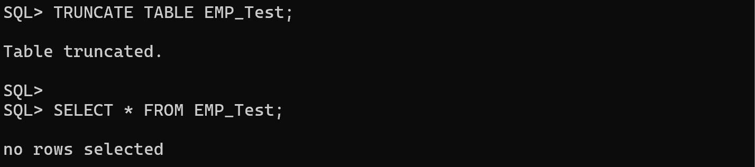
Question 20: Create Emp2 from EMP by copying only the EMPNO, ENAME, and SAL columns with data.
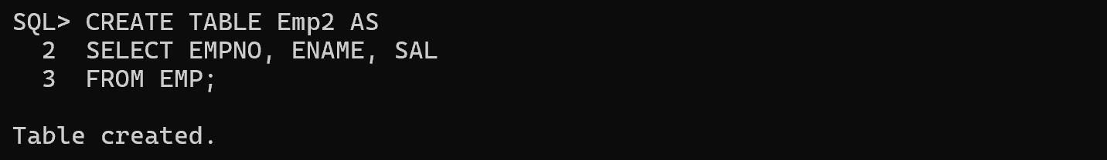
Question 21: Drop the Emp2 table.
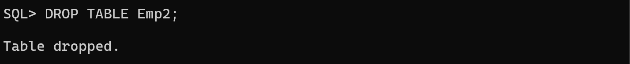
Question 22: Create the Emp2 table again from the EMP table without copying data.
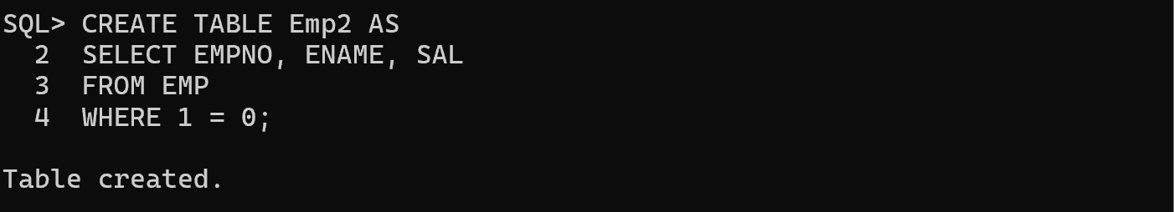
Question 23: Drop the Emp2 table.
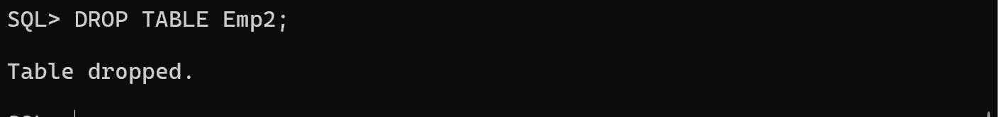
Question 24: Flashback the first Emp2 table that contained data and check your table.
FLASHBACK TABLE Emp2 TO BEFORE DROP;

SELECT * FROM Emp2;
Output:
ORA-38305: object not in RECYCLE BIN

Question 25: Flashback the recently dropped table by renaming it to EMP2_1.
FLASHBACK TABLE Emp2 TO BEFORE DROP
RENAME TO EMP2_1;
Output:
ORA-38305: object not in RECYCLE BIN
Question 26: Check your tables.
